**Introduction**

Modeled after the standard game of yahtzee. The program will catch invalid user inputs and disallow them from choosing the same category for points more than once. At the end their high score will be saved and they will be able to view the highest score recorded along with sample high scores will they will be able to sort. Categories at the end of the game can be searched through for zero scores.

**Rules of the game**

The player will be presented with a roll of 5 dice, they will have the option to re-roll each dice up to three times to match their dice to an optimal combination to get the most points possible. Round ends after 13 rolls.

Ones: Get as many ones as possible by re-rolling. Points are the sum of all ones.

Twos: Get as many twos as possible by re-rolling. Points are the sum of all twos.

Threes: Get as many threes as possible by re-rolling. Points are the sum of all threes.

Fours: Get as many fours as possible by re-rolling. Points are the sum of all fours.

Fives: Get as many fives as possible by re-rolling. Points are the sum of all fives.

Sixes: Get as many sixes as possible by re-rolling. Points are the sum of all sixes.

Three of a kind: Get three dice with the same number. Points are the sum all dice.

Four of a kind: Get four dice with the same number. Points are the sum all dice.

Full house: Get three of a kind and a pair. 25 points if valid.

Small straight: Get four sequential dice. 30 points if valid.

Large straight: Get five sequential dice. 40 points if valid.

Chance: You can put any roll into chance. Points are the sum all dice.

YAHTZEE: Get all dice with the same number. 50 points if valid.

Proof that the program ran at once point:

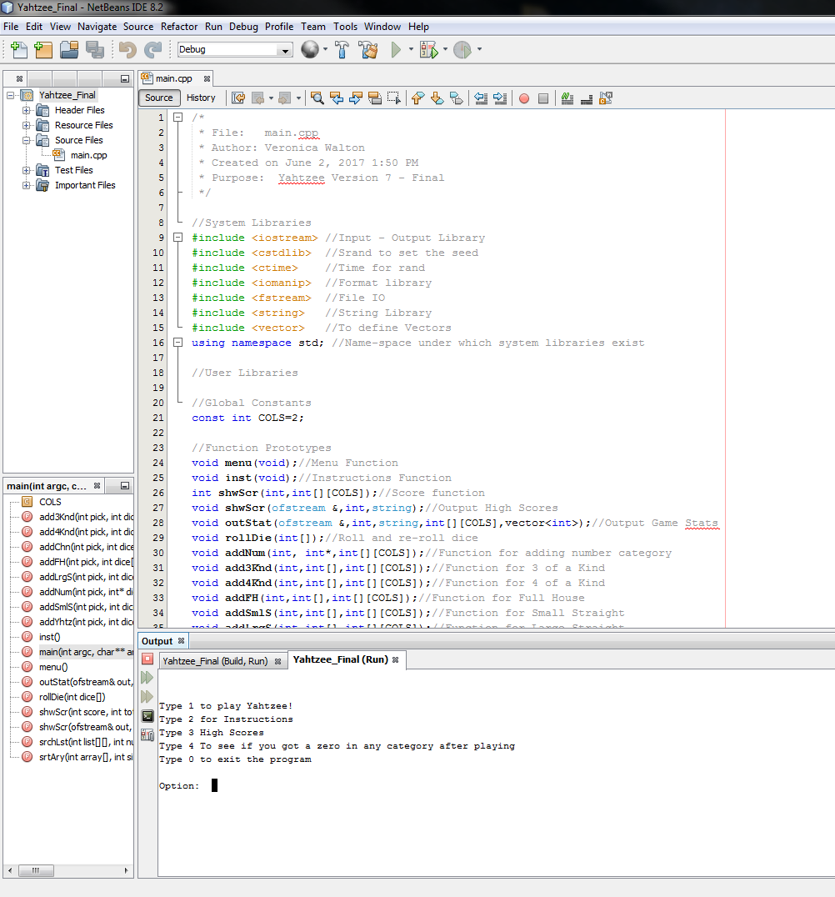

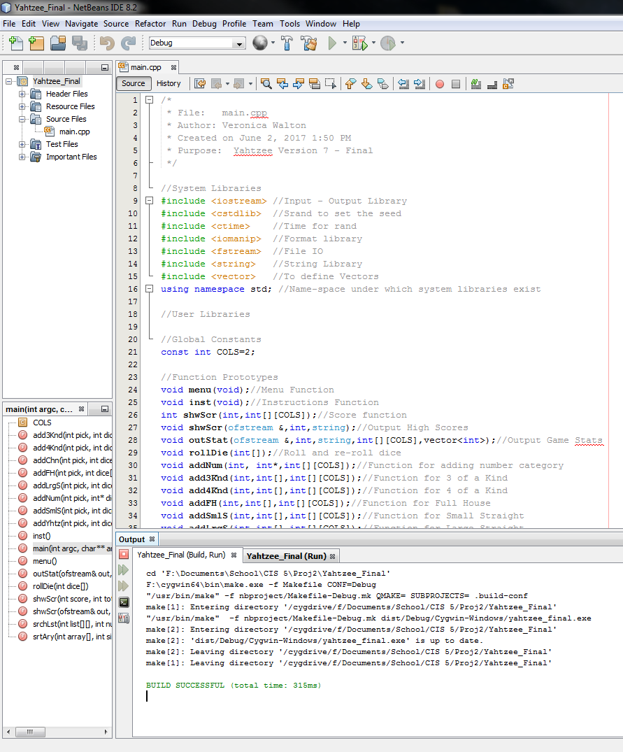

**Sample flow of game**

User goes into a menu, choose if they want to start the game, view instructions, view high scores or check categories after an already played game to see if they got a zero in any.

Once the user starts the game, they input their name and the first dice are rolled. They are asked if they want to re-roll, if no, they are presented with categories in which their dice will be judged to see if they fit the parameters. If they decide to re-roll they will be asked for each individual die, and then after the last die they will be presented with their new dice. They can decide to re-roll and do this process twice more for a total of three times before they have to settle with their dice and make a decision for scoring. This process repeats for 13 rolls because there are 13 scoring categories to choose from. After each turn they will be informed of how many points they received and how many total points they currently have. At the end they will be presented with their final score and their stats will be saved to a final. They will be taken back to the menu where they can choose from the other options including closing the game.